Muhammed Halbutogullari

913938544

LIN 177 HW 2

1)

The following pairs: [p] and [b], [k] and [g], [s] and [z] all exhibit the same relations between pairs: one is a voiced and one is a voiceless symbol. For example: p represents the plosive voiceless bilabial whereas b represents the plosive voiced bilabial. In these pairs, the first item is the voiceless version of the second (voiced) symbol.

2) For the rest of the assignment (including the prolog files), the word “Sym” is meant to be a variable representing a symbol from the input dictionary. We use the variable to map any character to itself. This way, we are avoiding writing a different transition for every symbol in the input language.

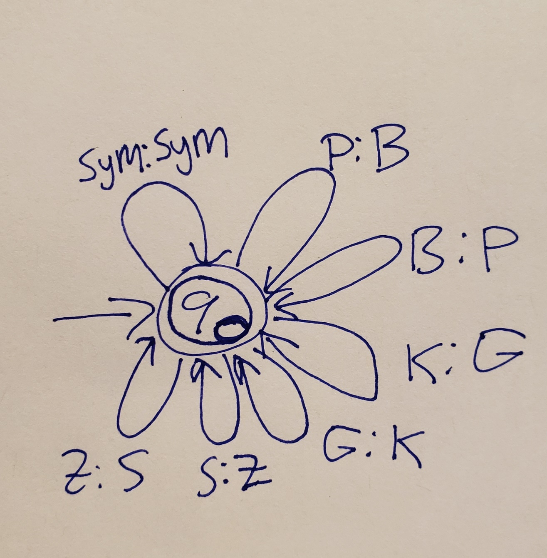

3) 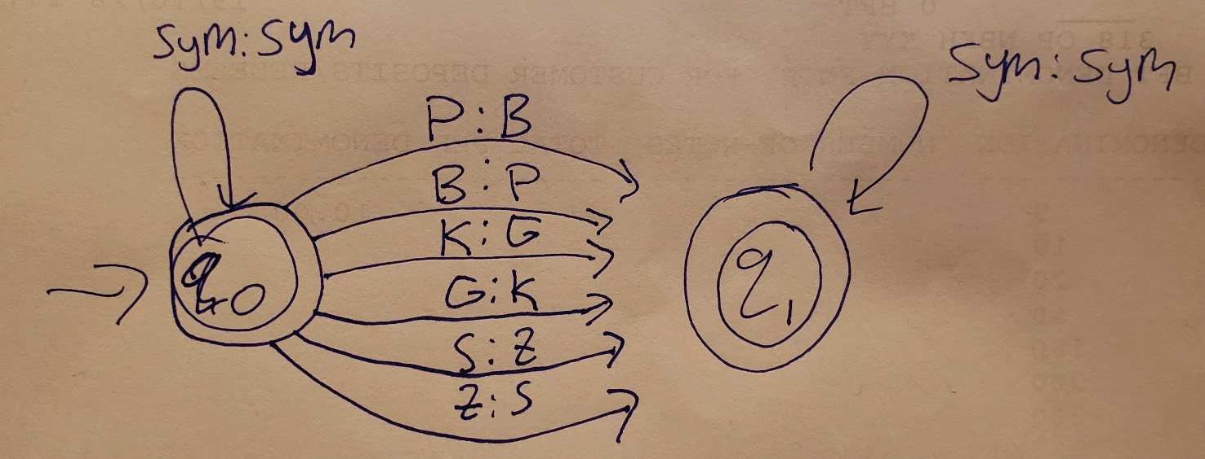

4)

